Final Year Project - UG

**School of Computing Science and Engineering (SCOPE)**

B.Tech. CSE/CPS/AL AND ML Capstone Project IN HOUSE Weekly Status Report – Week_08- 26.01.2023 to 01.02.2023

**Program: B.Tech. CSE/CPS/AI AND ML** **Batch: 2019-2023** **Course Code: CSE1904**

**Register No.: 19BAI1090 Name of the Student: ARNAB KARMAKAR Mobile No. 9721866757**

|  |  |  |  |  |  |  |  |
| --- | --- | --- | --- | --- | --- | --- | --- |
| Project Title: STOCK MARKET PREDICTION USING MACHINE LEARNING | | | | | | | |
| Technical Implementation Steps & Programming Tools:   1. Simple Convolutional Neural Network and ANN- construction and generation of synthetic data from user defined input. 2. Python libraries related to Deep Learning (eg. Caffe, TensorFlow, Keras, sklearn-theano). 3. Deep Learning (DL) libraries used for synthetic data generation (eg. Datawig) that can work with both CPU and GPU. | | | | | | | |
| **26.01.2023** | **Start working on the Python implementation and perform normalization of data.** | | | | | | |
| **27.01.2023** | **Learn how to configure container and install all dependencies.** | | | | | | |
| **30.01.2023** | **Load the Test List and the Target List into the Confusion Matrix function.** | | | | | | |
| **31.01.2023** | **Execution of scripts to generate maps.** | | | | | | |
| **01.02.2023** | **Start deploying the CNN and ANN model with SVM.** | | | | | | |
| **Implementation** | Patent / SCI / Scopus Indexed Journal Paper / Scopus Indexed Conference Paper/ Scopus  Indexed Book Chapter SCI | | | | | | |
| **Work Status** | ✓  ***Excellent*** | ***/*** ***Good*** | ***/*** ***Satisfactory*** | | ***/*** ***Needs improve*** |  |  |
|  | | | | |  |  |
| ***Attendance Status*** | ✓  **Regular / Irregular** | | | ***CAM – Max. 5 Marks per week*** | | 5 |  |

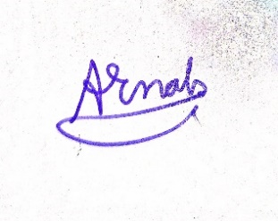 

20/1/23

20/1/23

**Signature of the Student with date** **Name & Signature of the Guide with date**